MA374-LAB3
Nikhil Agarwal
Roll:11012323

1.
Observation:

For set 1 The value of American call is 12.08538001.
For set 1 The value of American put is 5.26674760.
For set 2 The value of American call is 12.12304707.
For set 2 The value of American put is 5.27983715.

Graphs:

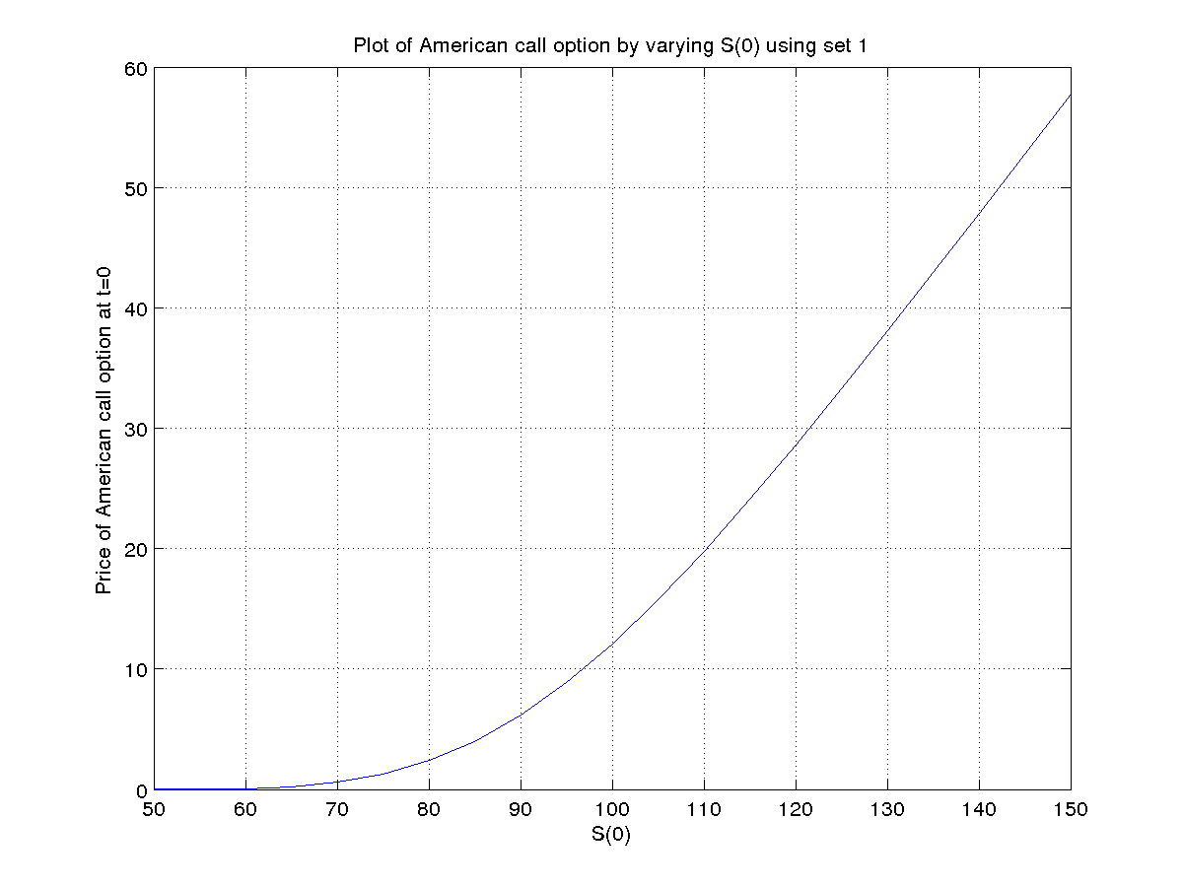
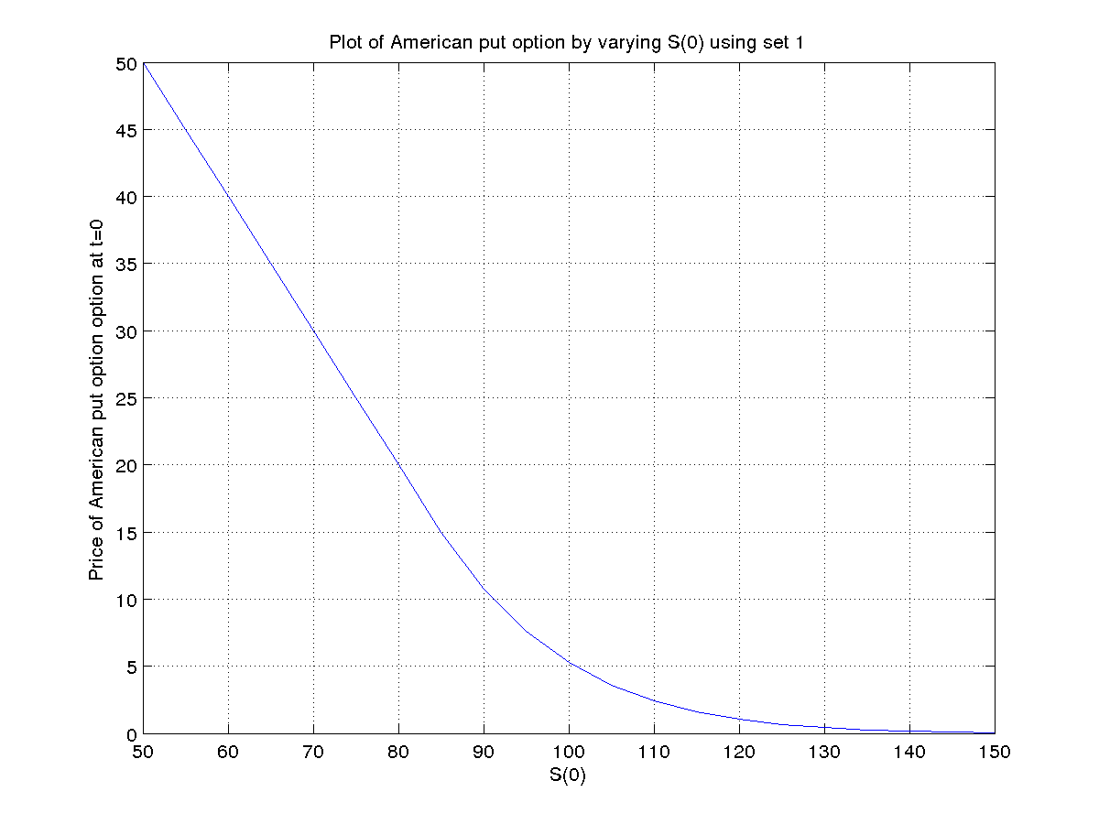
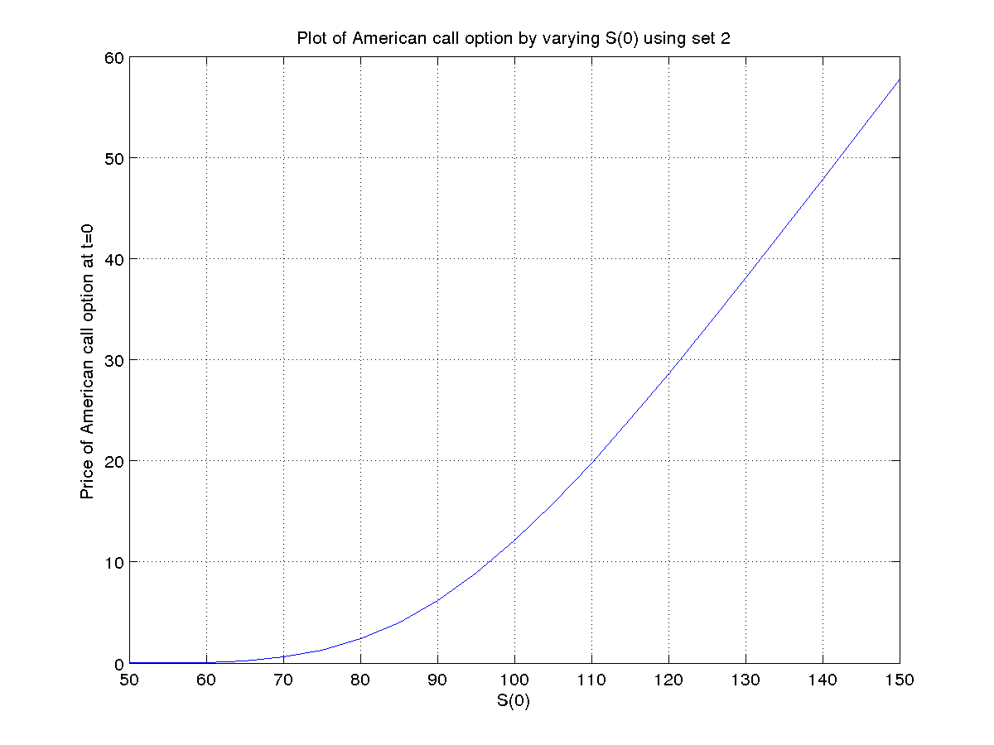
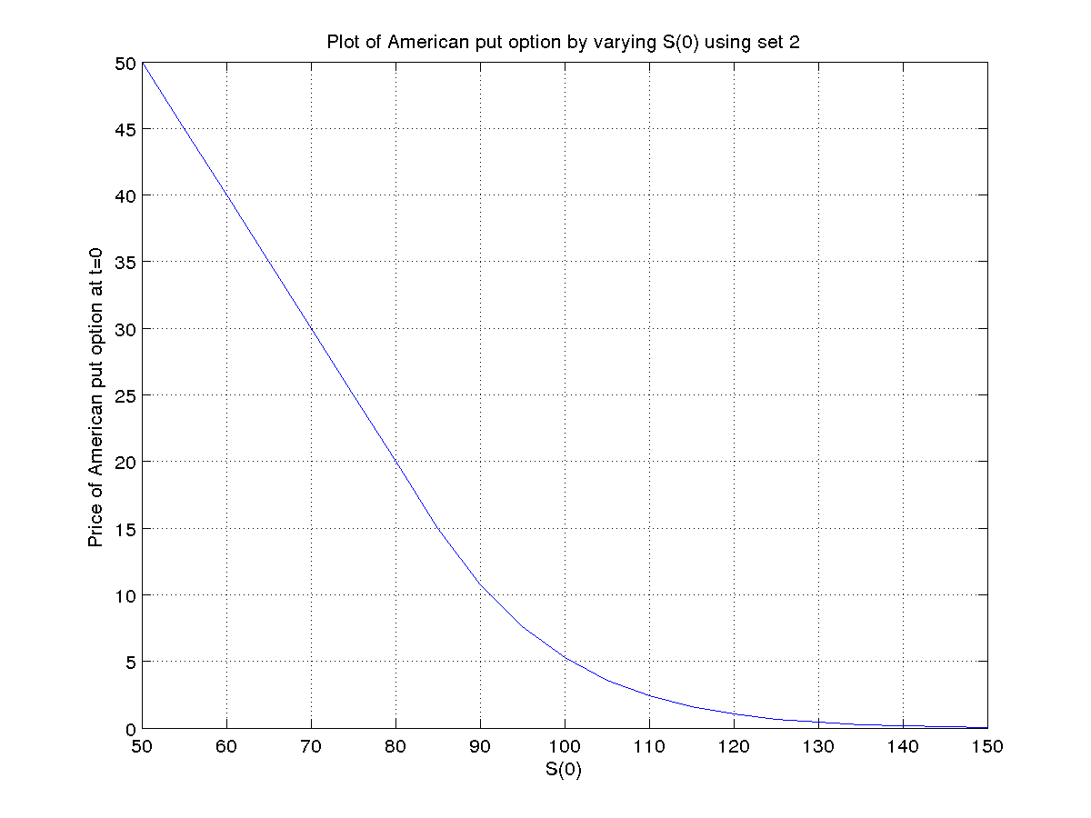
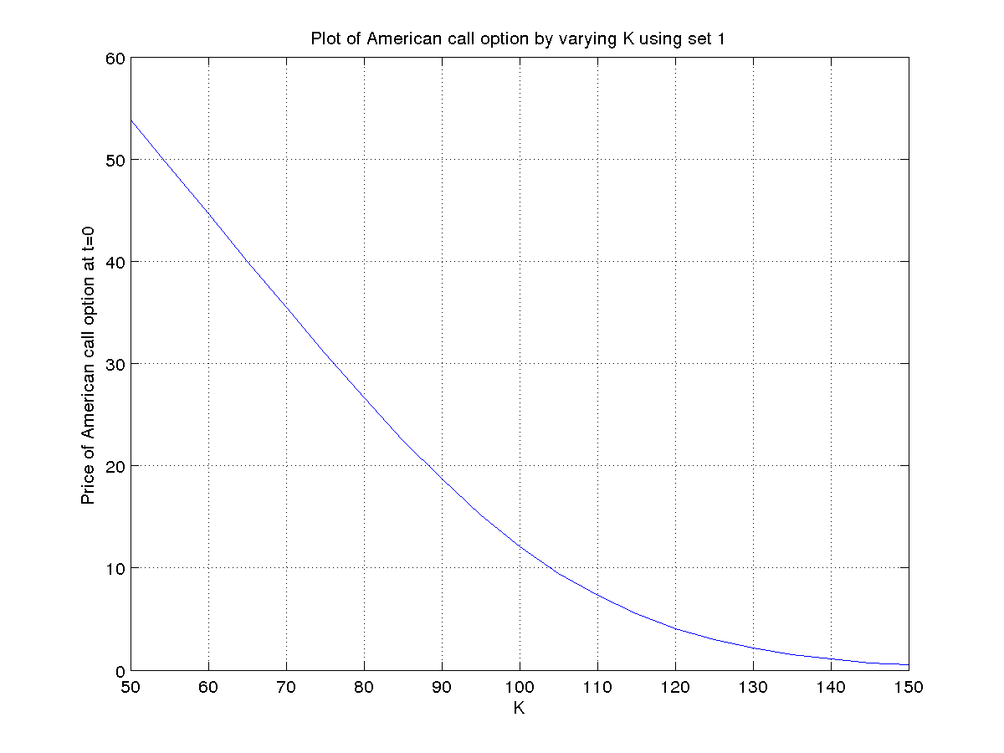
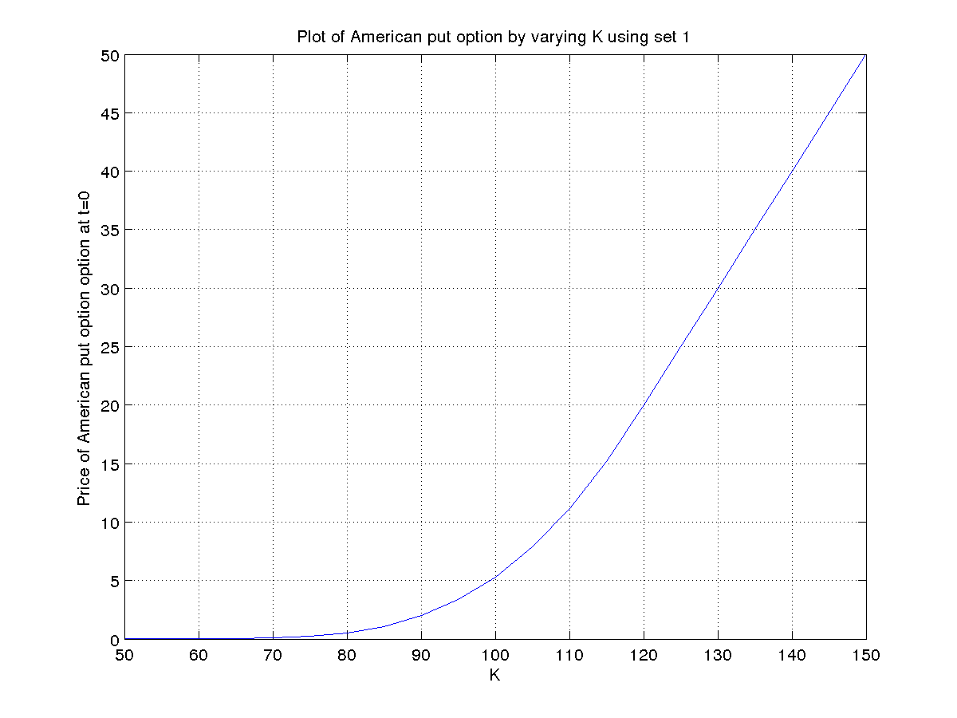
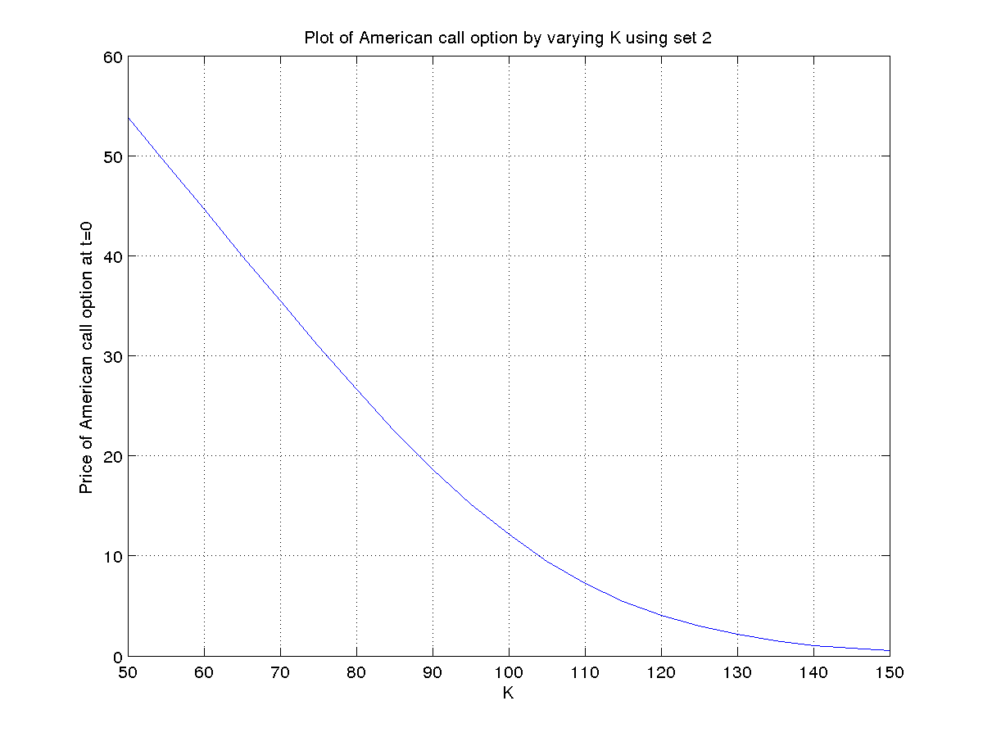
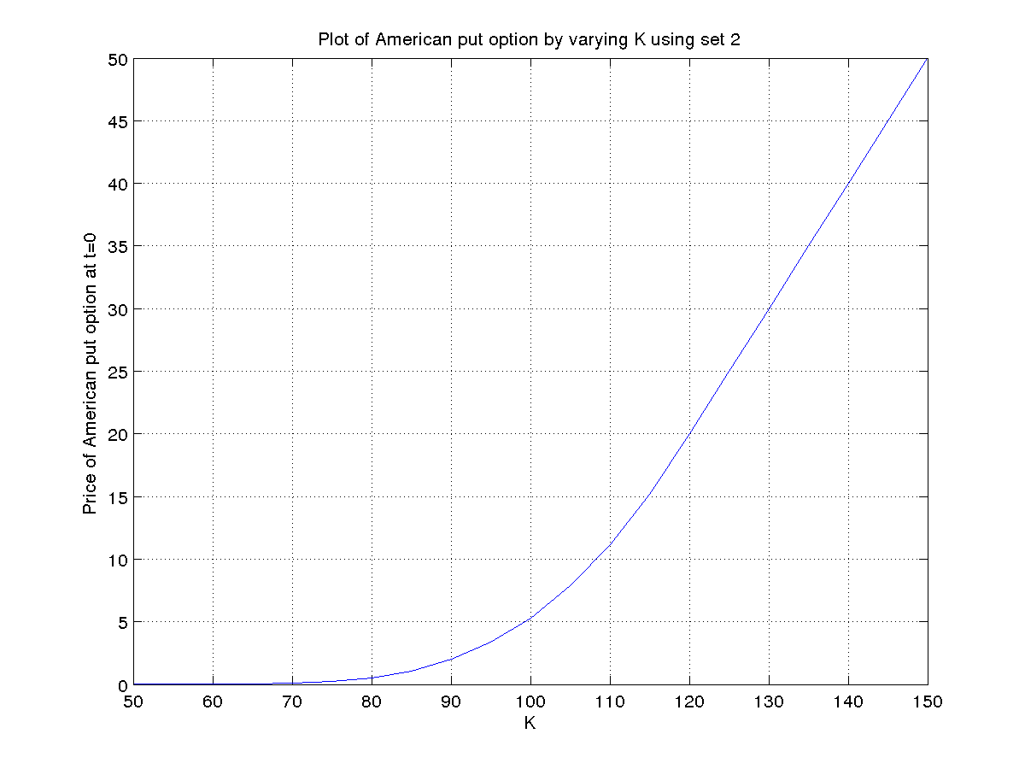
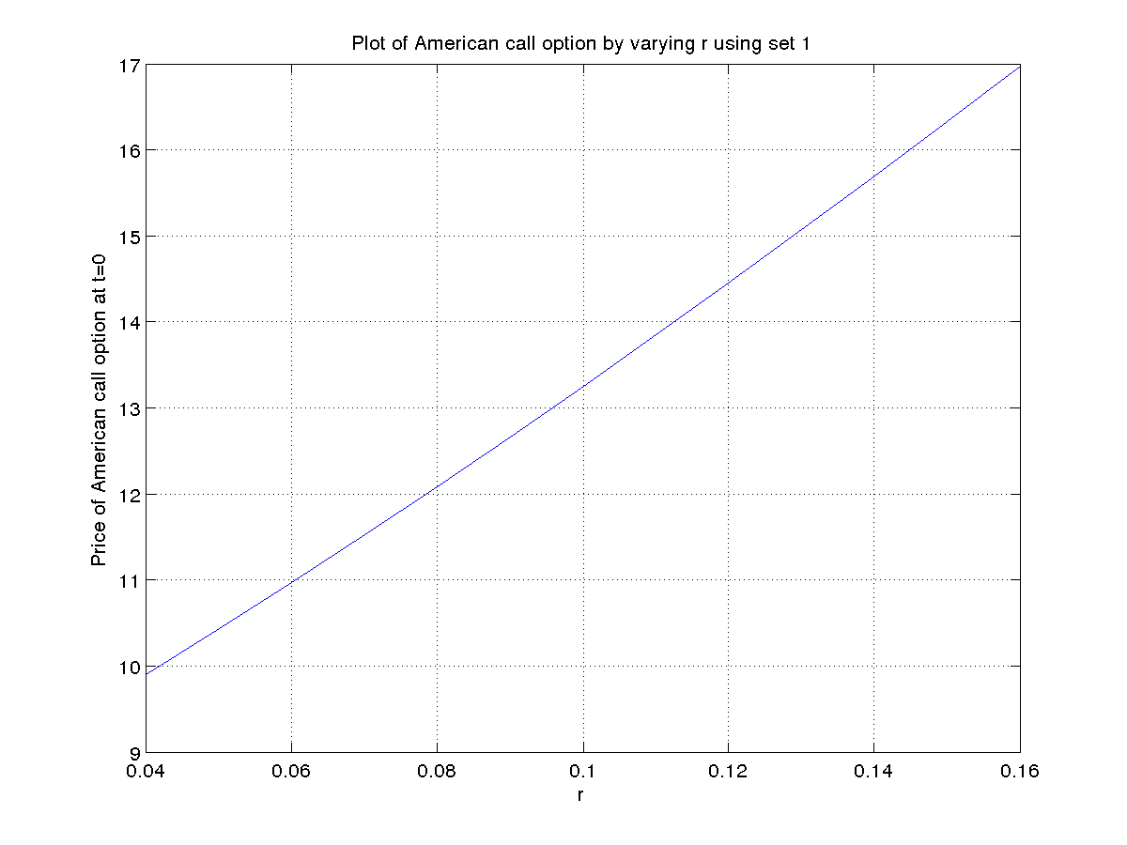
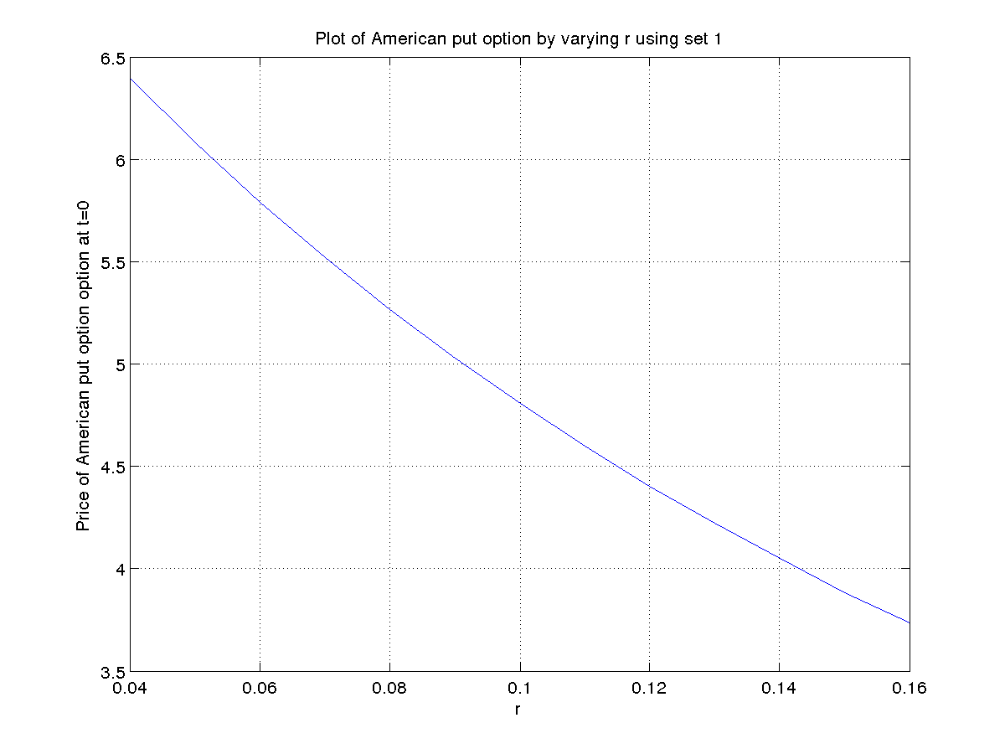
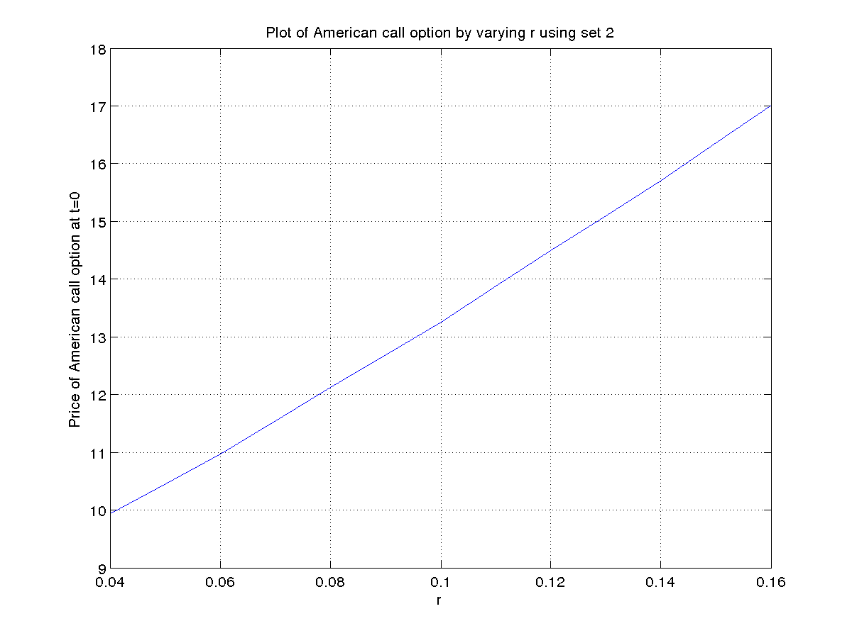
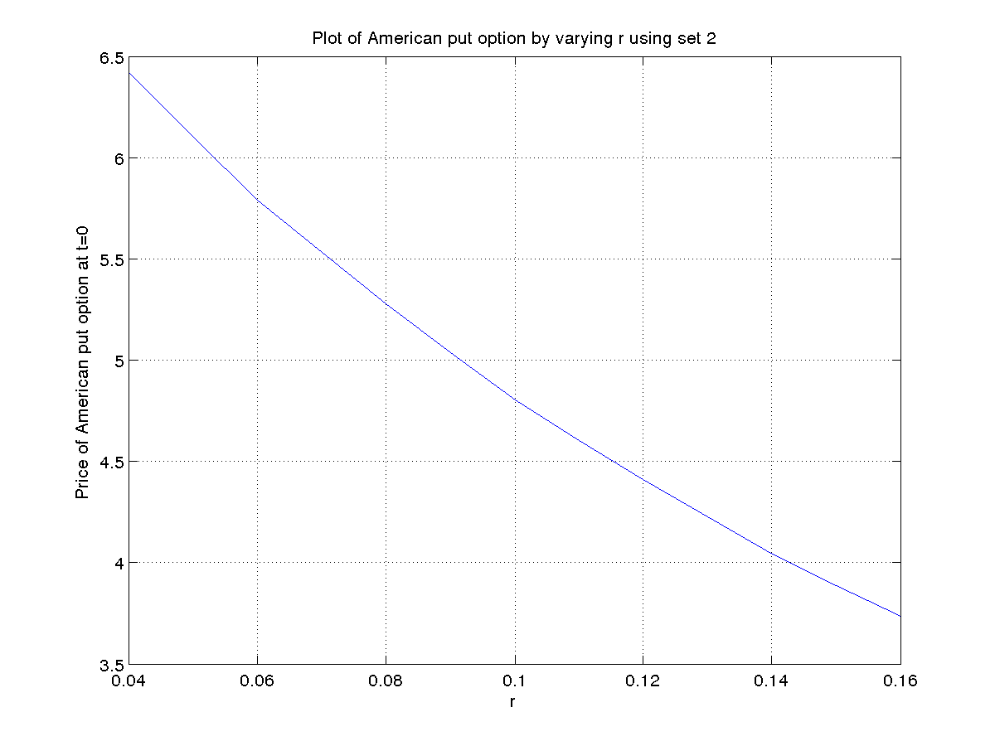
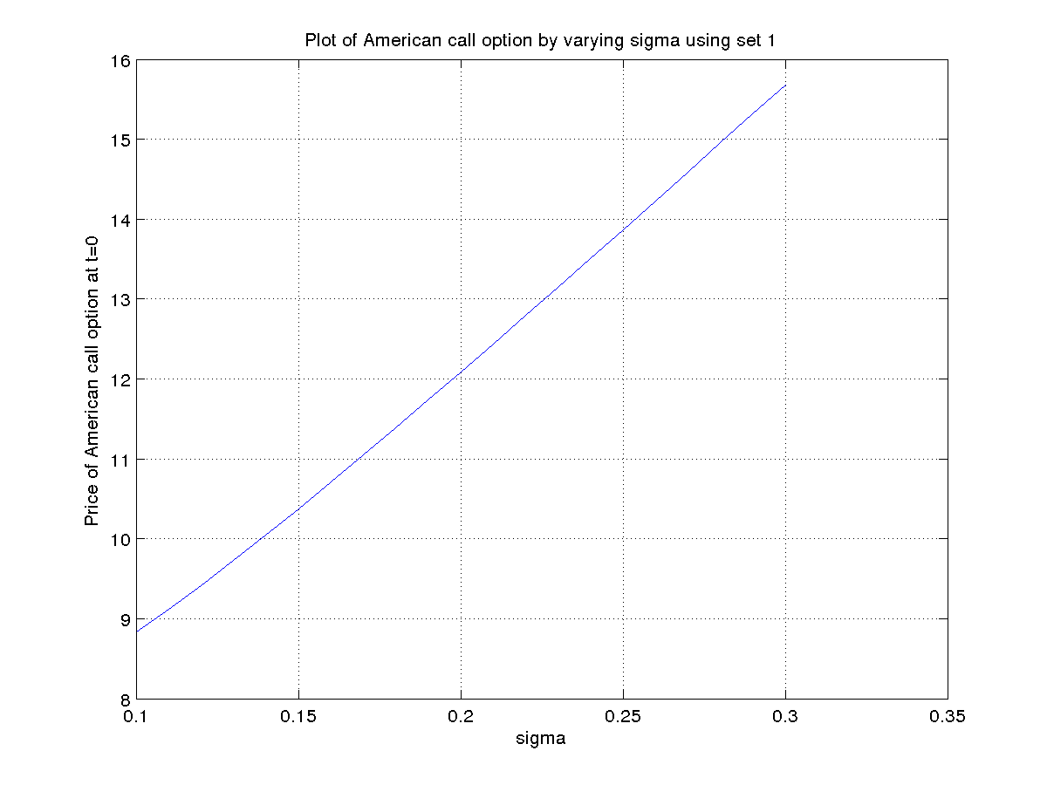
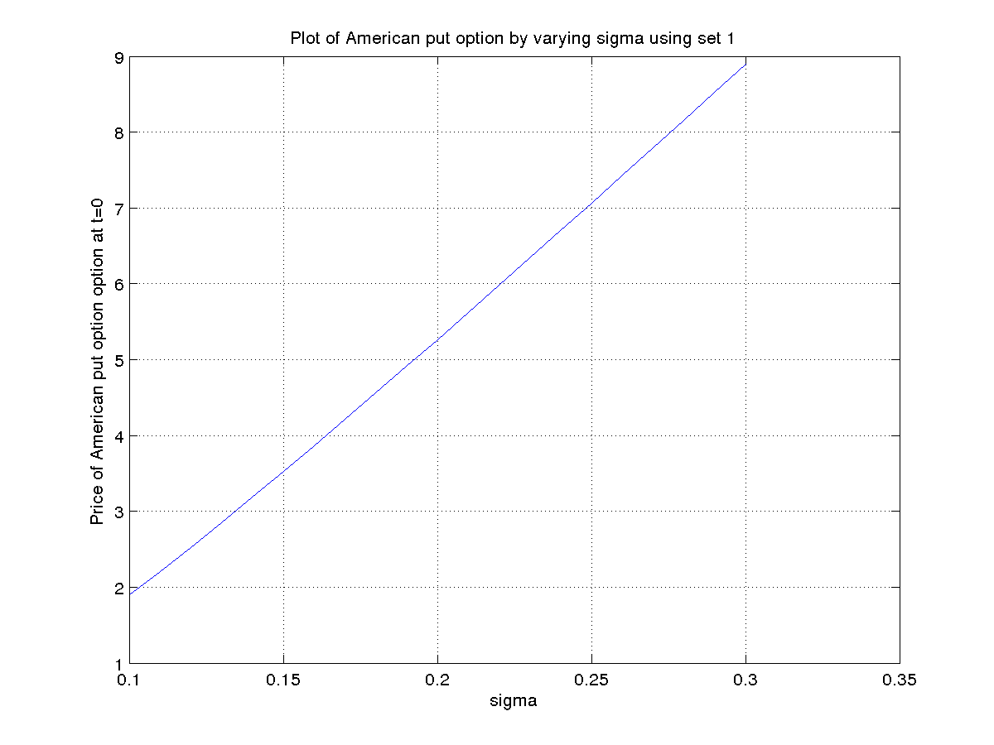
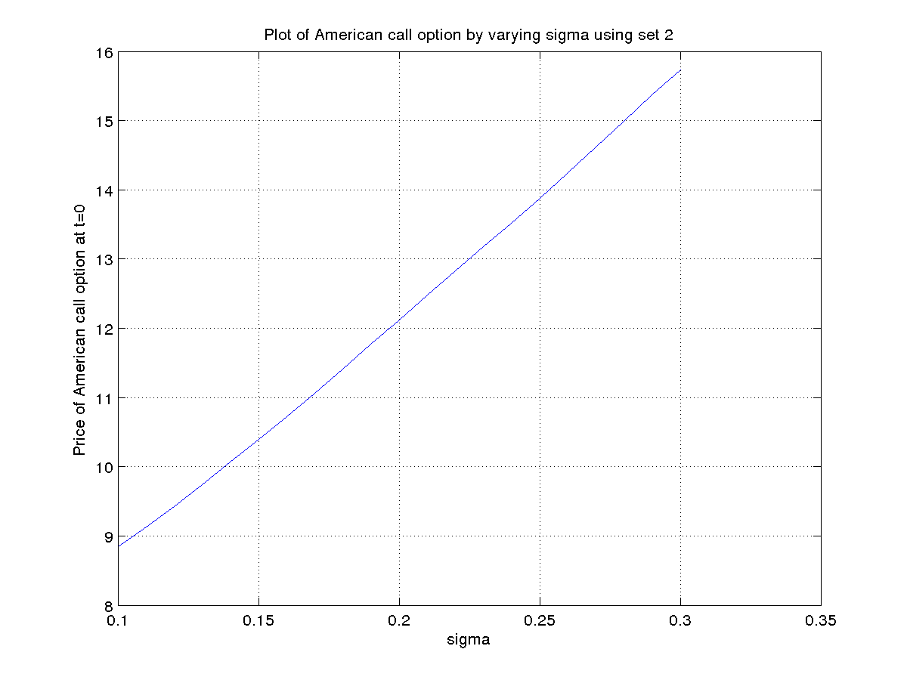
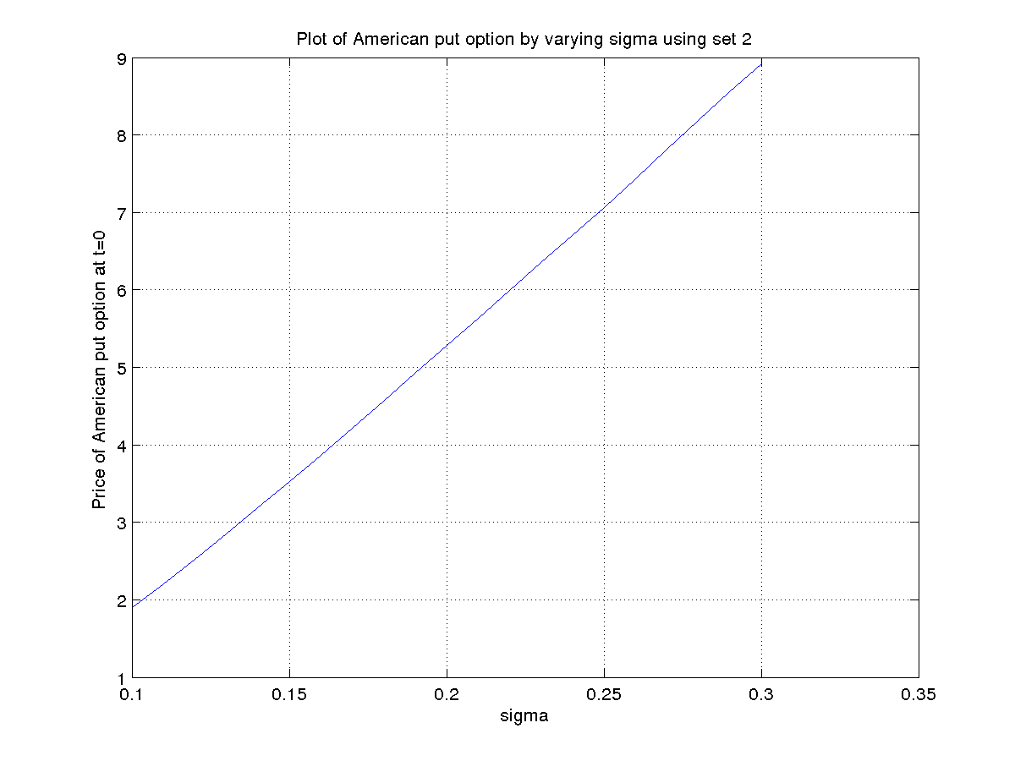
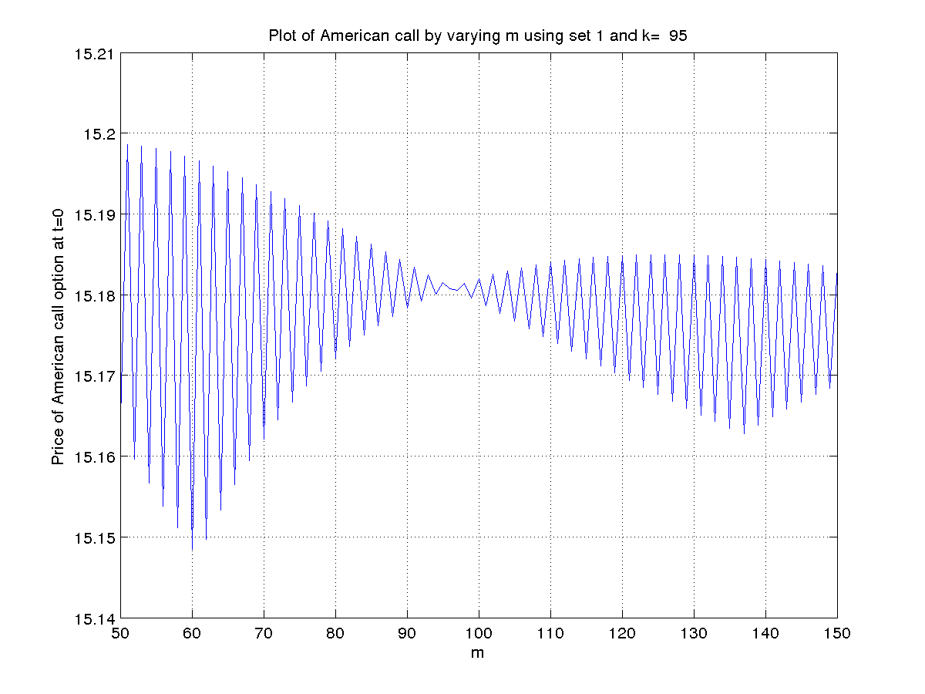
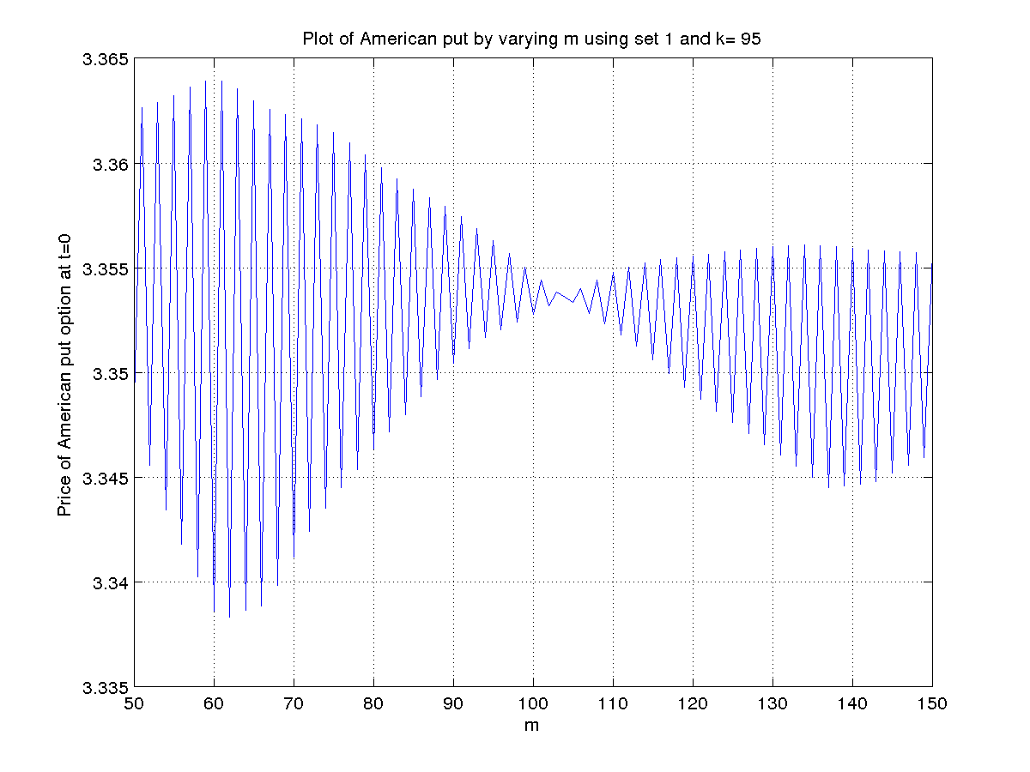
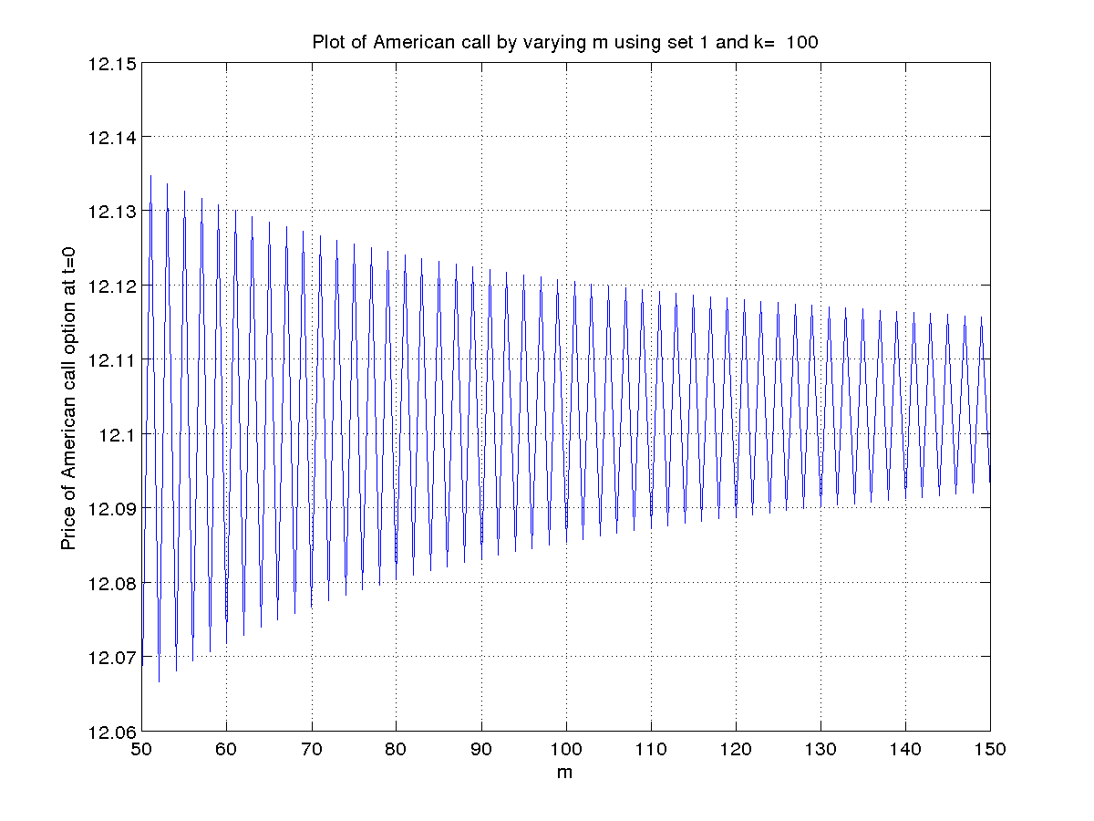
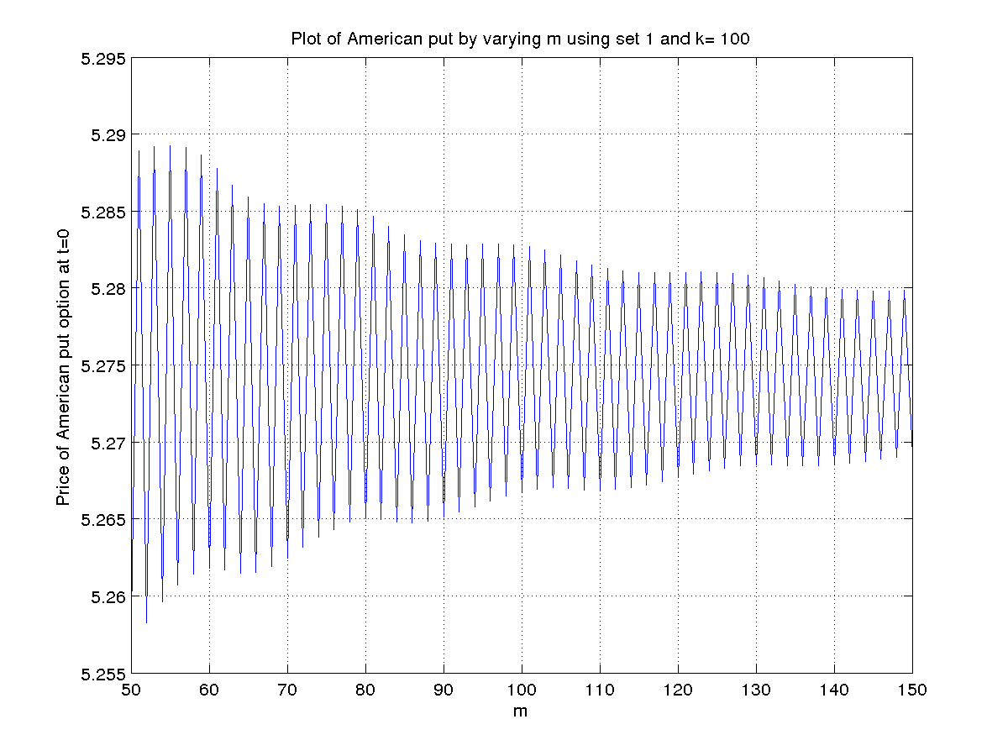
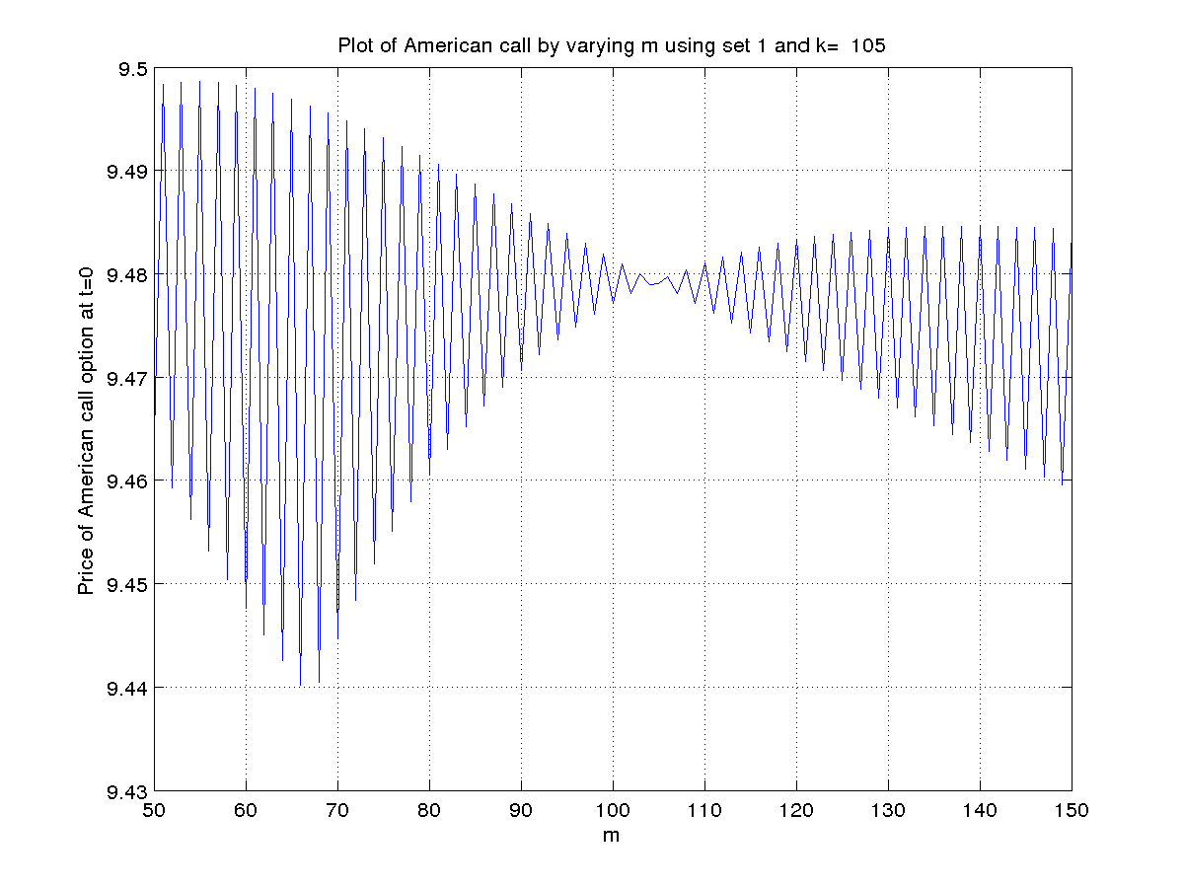
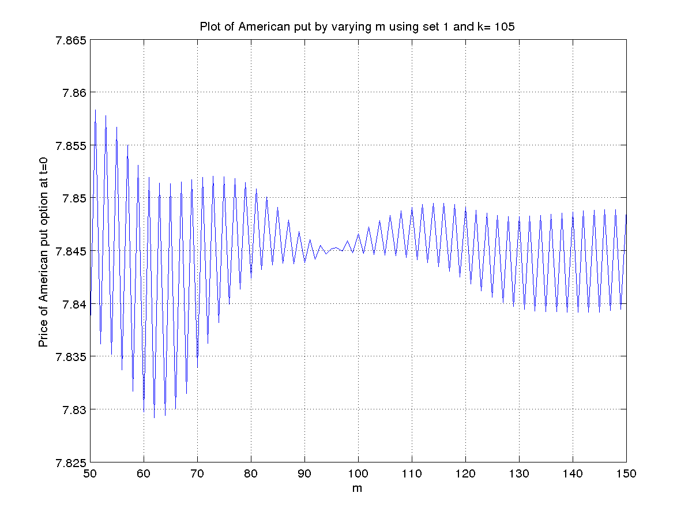
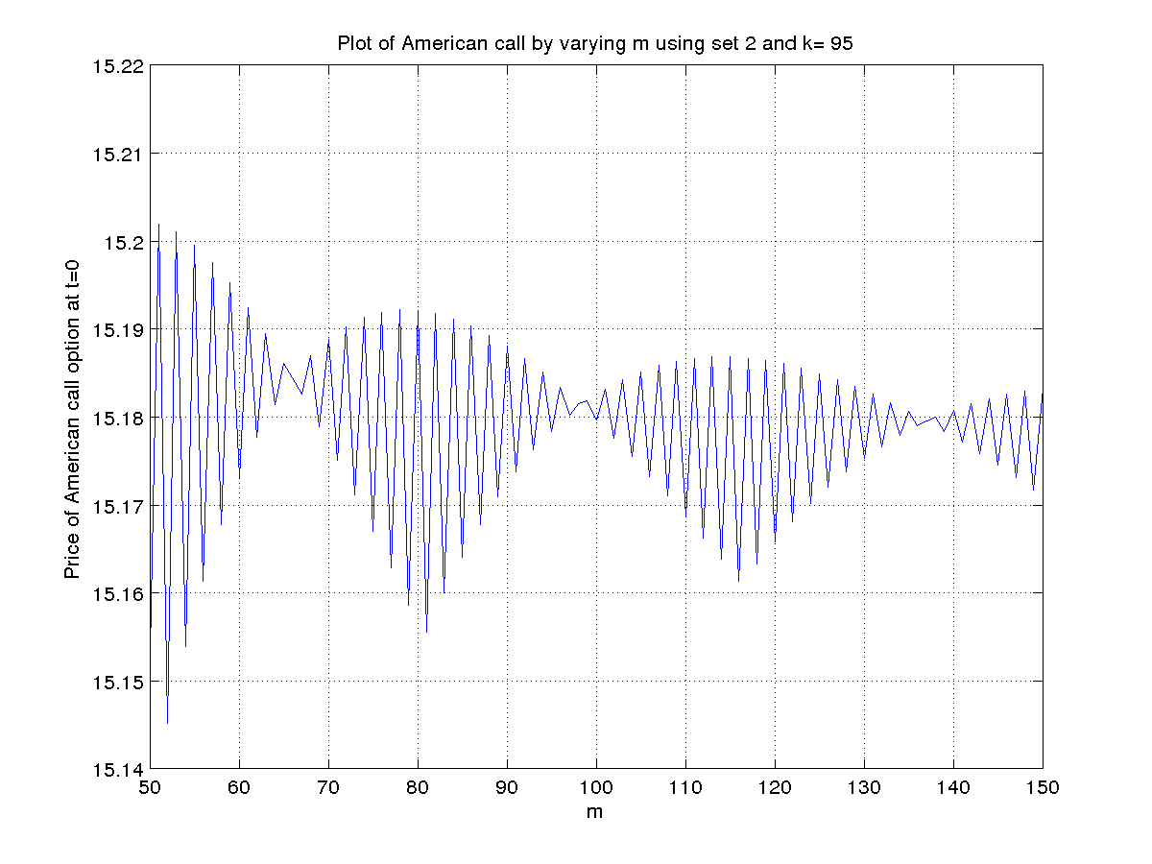
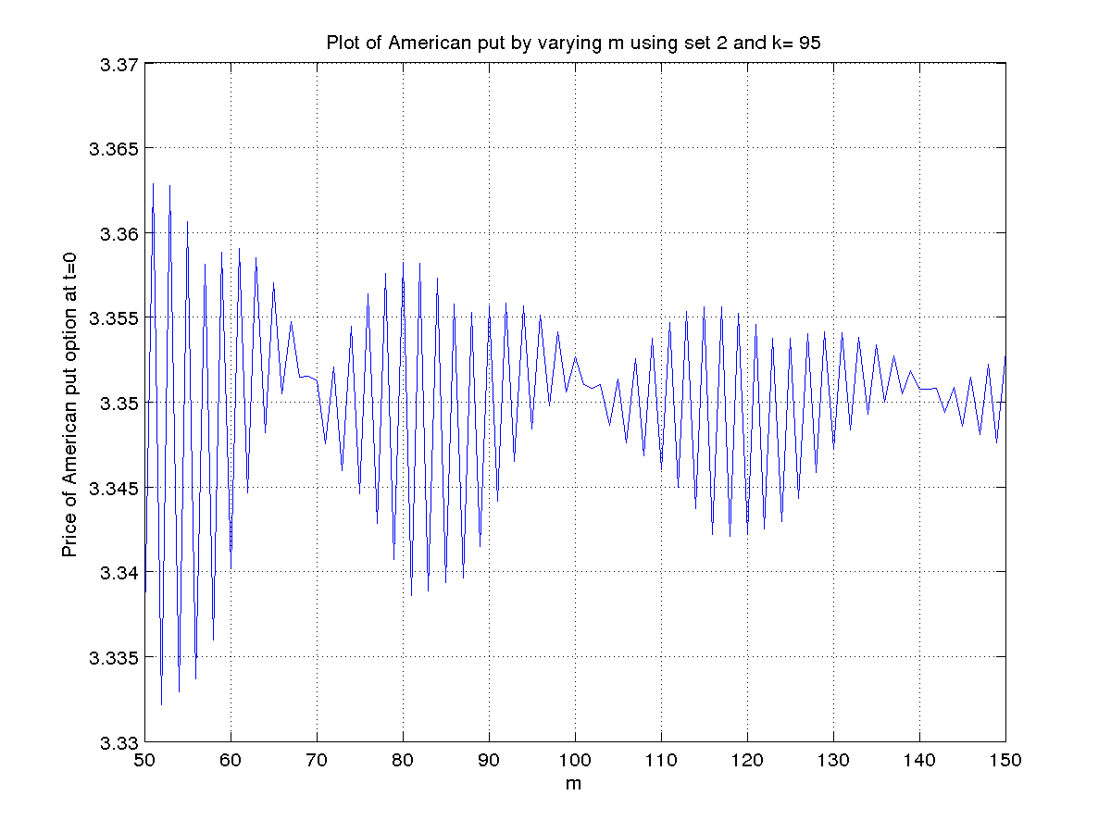
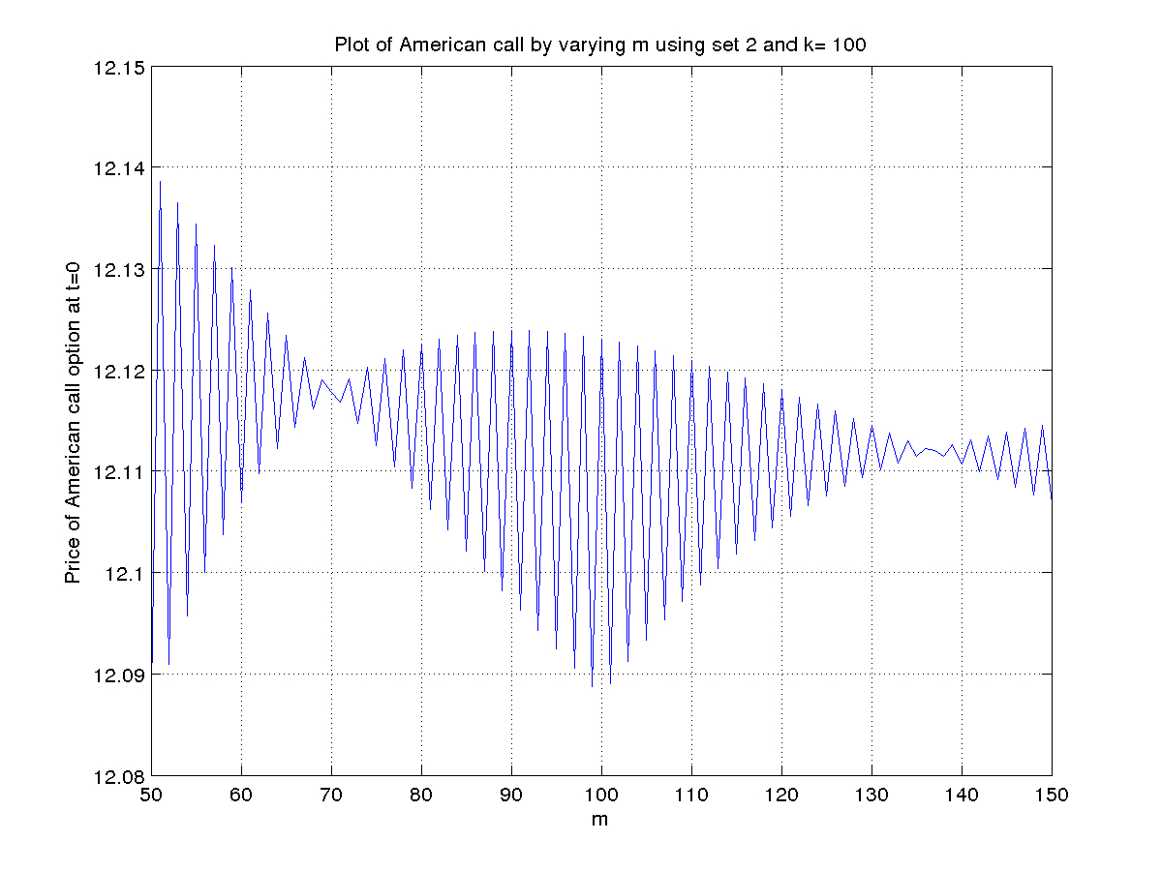
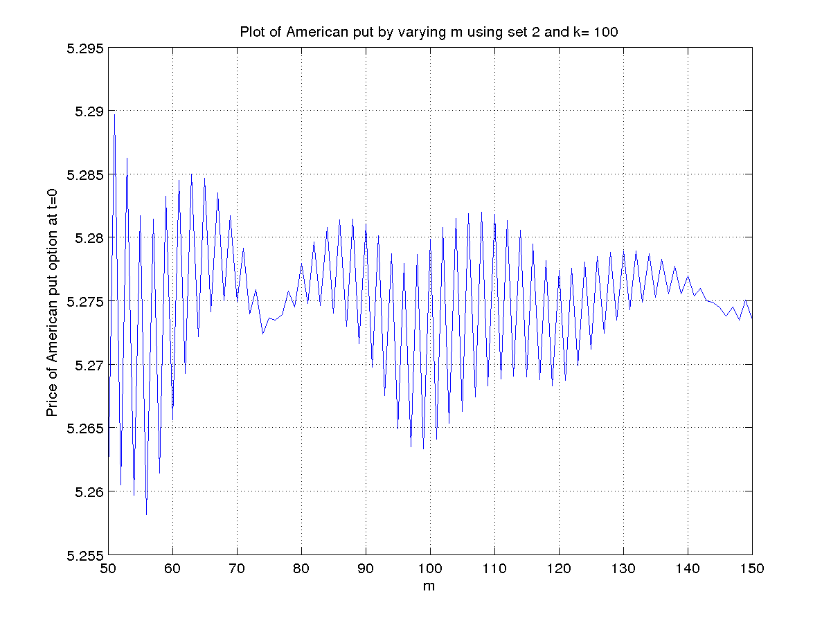
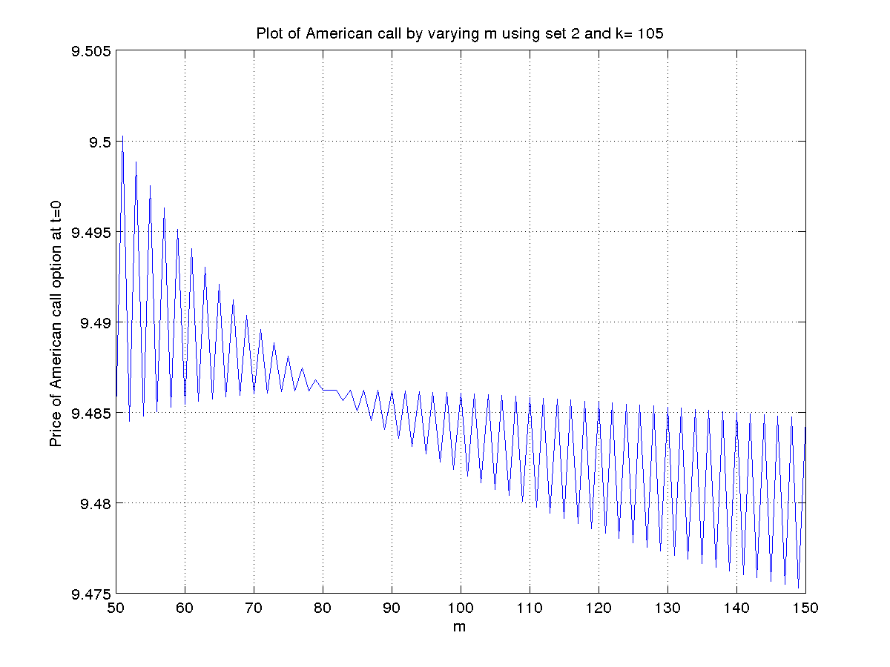
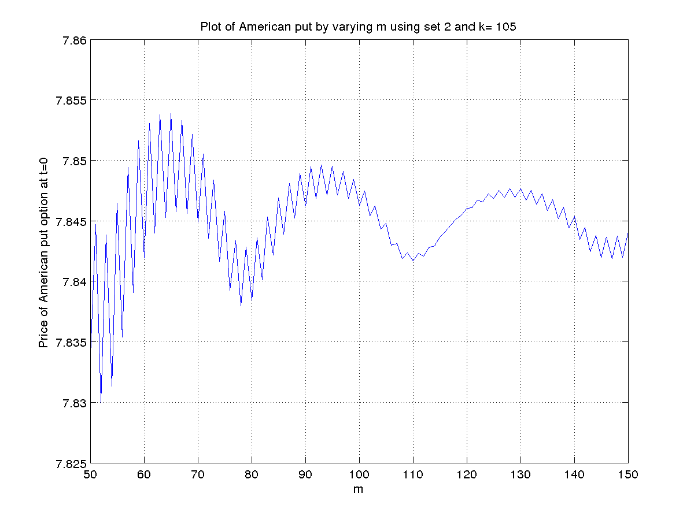

2. Observation:
a. The value of Lookback option at m = 5 is 9.11929899.
The value of Lookback option at m = 10 is 10.08058291.
The value of Lookback option at m = 15 is 10.51916460.

b. Values of options at t=o for different value of m :

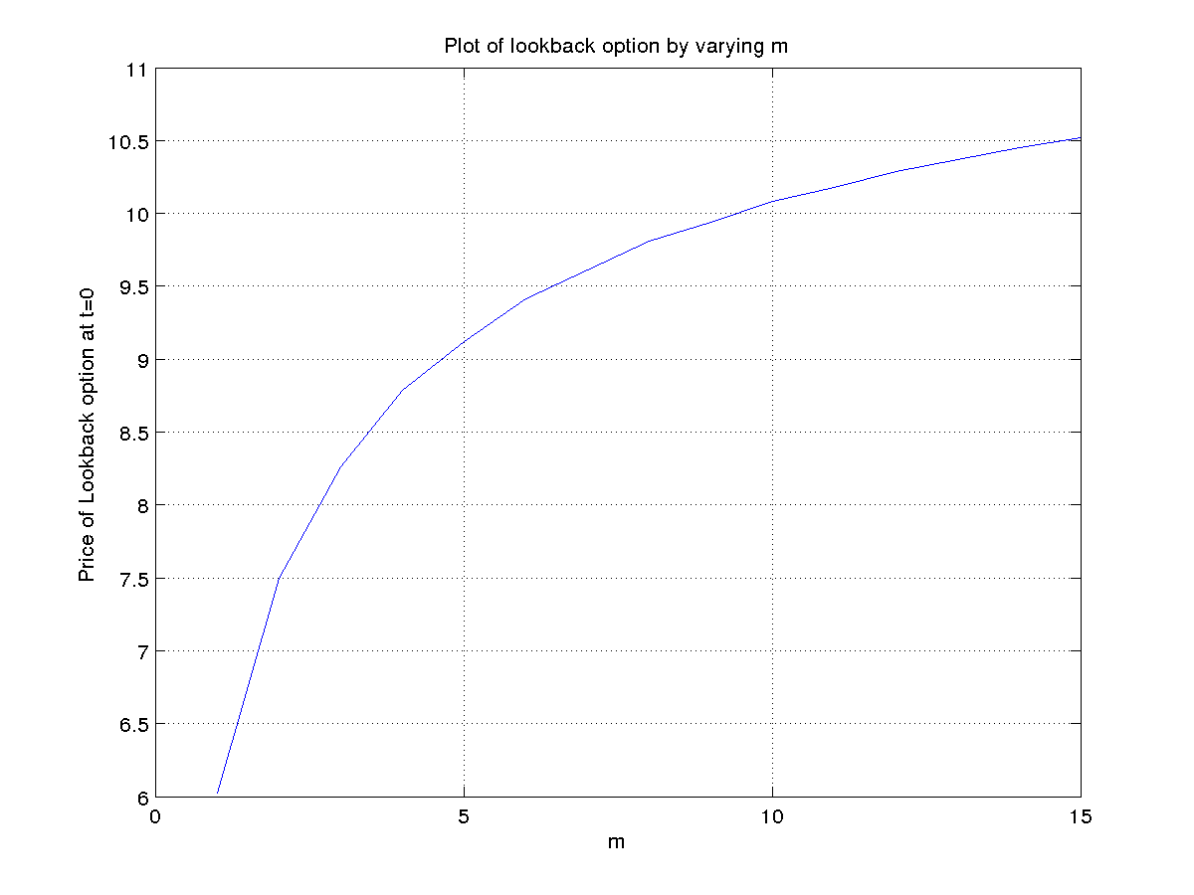
- Value of options at all intermediate time points for m=5 is

t | Value of Lookback option
0 | 9.119298985864701
0.2 | 9.027951165547773  9.504839866450867
0.4 | 8.548076183576464  9.799118753547043  7.147915756774757  12.168664659721799
0.6 | 7.416771005131031  9.955271272957836  6.201916453882765  13.712862965988544  6.201916453882765  8.324614669633151  7.148418208190115  17.582062714095425
0.8 | 5.501638813874003  9.571391531700243  4.600479677676443  15.631851880479847  4.600479677676443  8.003613780975460  6.680842999256649  21.188089345345645  4.600479677676443  8.003613780975460  3.846928884415620  13.071380970928784  3.846928884415620  10.680904426029940  10.680904426029961  25.051229457037032
1 | 0  11.181413117784530  0  19.452691543130413  0  9.349916553291678  6.374517470614265  25.394563475064984  0  9.349916553291678  0  16.266373556657399  0  13.578002496522672  13.578002496522657  29.482597122270590  0  9.349916553291678  0  16.266373556657399  0  7.818416029586729  5.330382286201811  21.234976911949744  0  7.818416029586729  2.901350497139646  18.805945122887579  2.901350497139674  18.805945122887593  18.805945122887593  32.105394038530477

